**Members**: Ryan.S, Austin. H, David. H, Katie. N, John. L, Josh. R

**Software Engineering (CIS-4150)**

**Software Engineering December Check-in & Review**

**Outline:**

Our class project was to create a website for Northern Psychiatric Services. Our team was tasked with creating the WebUI. In the beginning, we planned to make improvements on what the previous semester had done, but as the semester went along, we decided to make some much-needed changes and slowly moved away from what was there. Some of the key updates we made were:

* The inclusion of a working calendar that will display and manage appointments.
* Updated & better formatted CSS styling
* Implemented more HTML, allowing the website to be more portable
* Created a note-taking system for practitioners and students so they write down patient’s complaints.
* Use of Frames to separate windows
* Moved patient information from the header to its own window/HTML page, for security reasons

**Features Implemented:**

* Set appointment date and time
* Choose preferred times of day
* Set the type of appointment
* Have Separate patient records
* Allow patients to be able to specify their preferred or previously visited doctors
* Update patient information/records
* Send out a lab order
* Send out a prescription order
* Take notes while in an appointment
* Fill out a financial form where the data is sent to another page that displays it, the PHP for it however doesn’t work.

**Features Cut/Unimplemented:**

* Database Integration
* PHP (Partially)

**UML Process Diagram for Website** (Proposed Sept. 19th):

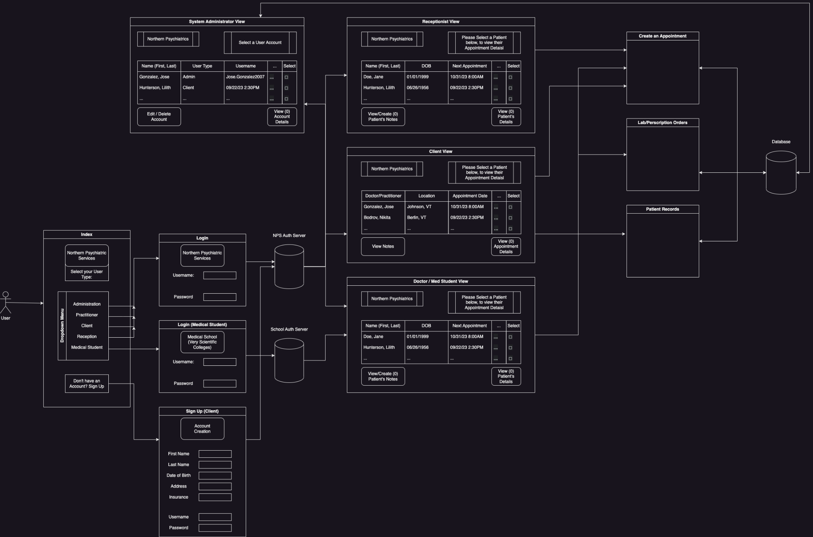

Member Notes:

**Austin:**

“For December, I began utilizing the revamped calendar to implement php as the database was finally built. I am rough with how to precisely use PHP and the SQL commands, however, I believe I made my best attempt at utilizing it. What I mainly did was attempt to make a php version of both of my pages which did not end up working for unknown issues. We were limited by time to solve the issues. As for viewing the project as a whole, I enjoyed working with others to reach the same goal. The diversity of work between groups was interesting and the way that we interacted between groups I felt went very well. My only concern about the project is that we may have been a bit too ambitious in the beginning, which lowered our envisioned end goal. We also had a problem where for the first few weeks, we did not understand how to move forward which came back to bite us in the end. If we had more time (say the amount we had wasted in the beginning), I feel that we would be much closer to what our true endgame was. Other than that, I felt that the project was a great way of showing how to function, work, and act as a Software Engineer in the field! 7/10”

**Ryan:**

“In between the end of November and now (12/14), I haven't added much to the project. I have mostly been focusing on getting everything secured and working from all of the groups, such as moving the HTML and PHP code onto the GitHub repo and then getting all of that onto the Lemuria web server for demonstration. As well, I've tried to coordinate ideas with the other groups and ensure we’re all on the same page.

Reflecting on the project this semester, I feel as though we had a lot of ambition for the project, a lot of that having been able to be implemented. Maybe it’s overambition or naivete, but I was hoping we’d be able to have the database working, and much more implemented before the final draft was released. Sadly, due to some oddities with Lemuria, a lack of total knowledge of PHP and databases, and general scheduling issues, we were not able to do so. However, I feel as though we did still succeed at our original goal: Take what the previous semester did, and improve on it. We included HTML code now, so that whoever picks up the project after us can more easily view what we did (which is something that the previous class did not do, making it difficult to start working on the website). Overall, we had 10/10 ideas, but I’d say our project was a 7-8/10 overall.”

**David:**

“In December my main priority was finishing up the HTML of the billing statement page and making a new page where the information from the billing statement page would be displayed. During this time I talked with the Money group and we agreed. Because of a lack of time, having not used PHP in years, and their eagerness to help, I let Cody handle the PHP of the Display page, and Nick would initially work on the PHP for the main billing statement page. During a check-in I had earlier this week with the Money group, Nick agreed to have Luke handle the PHP of the Billing Statement. Over time the Billing Statement page shrunk down slightly as per Luke’s recommendations. Even though there were unforeseen issues with the PHP in the final build, I am proud of what we were able to complete in the allotted time. I say the biggest issue with the project was how unevenly the groups were split up, which was exacerbated in the last month when one of our classmates went MIA. Overall I say the Software Engineering class project for me was a good experience in working with unfamiliar classmates towards a common goal.”

**Katie:**

“During December, I have worked on adding PHP to three of the four pages that I have contributed to our project. However, due to our lack of being able to connect to the database, none of the PHP is being included in the final build. Overall, I think that working on this project with a group of students similar to myself has taught me lots of valuable things. It has been interesting to see the specific skills that each student can contribute to the project. When each of our skill sets are combined, it is amazing to see what can be accomplished. I think that given more time and resources, we would have been able to achieve all of our goals for the project, but given that the students had a few months (and several other classes on their plates), I am not surprised with what we ended with. In the end, I think we all learned a lot about what the processes of software development look like. To me, that is the most important thing I got from working on this project. Considering that, I’d say our project was 8/10 because of how much all of us learned these past few months!”

**John:**

During December I completed and improved on the previous template I made for the pharmacy page in November. Admittedly, I wasn’t able to do a ton but still did my best to contribute to my group in whatever ways I could. I wrote up the pharmacy page of the site which, while a bit small, went through quite a bit of drafts through the course. This month I also made a mockup for how the patient history and my page's medication history would look consolidated. I did my best to do work as I was asked and work with what was given, but through the class worked how I could.

For the project itself I think we did pretty well. It certainly wasn’t perfect, but we learnt a lot. Even if we didn’t fully fufill our goals, given a bit more time I’m confident with the skills we elearnt we would’ve been able to. I’d score our project around an 8/10.

**Josh:**

“For the December portion of the project, I haven’t contributed much in terms of significant parts to the project; the two pages I had created, the medical record, and patient history page were, for the most part, complete. I made some small refinements such as the sizes of the tables needing to be relative to each system within the problem list. However, the majority of the time was spent researching and attempting to integrate the necessary PHP script into the pages. With a collective effort amongst multiple members of the class, we have been working on establishing a connection to the database, but have been unsuccessful so far.

In hindsight, I see this project as being generally successful. Yes, the goal was to develop

an electronic medical records system, which given a larger window of time, I'm confident the

class can complete as we've made great strides so far. However, the real end goal was the

collaborative work each of us was able to experience firsthand which provided us with an awareness of what it takes to jump into the field of becoming a software engineer. Additionally, I would score our project an 8/10 in reflection.”

Progress Updates:

**September:**

For the Interface group, [Ryan] contributed a general UML diagram depicting how we feel the website should flow, as well as designing one part of the website that Is integral to the practitioner, the Doctor’s view during appointments. The doctor’s view would include (as of current) a three-pane window, with the patient’s info on one side, notes on the other, and some appointment-specific information in the middle. [The Interface group] plans to have it incorporate tabs to allow the doctor to switch the middle content out, depending on what they need (Prescriptions -> Calendar). Aside from that, we have been helping organize what members of the group are doing, as well as coordinating with the Work-orders group to assist both our groups in figuring out where we stand, and to get a framework we can work from that can pull from a database.

* Kathleen - 15%
* Ryan - 15%
* Austin - 15%
* David - 15%
* John - 15%
* Josh - 15%
* Alex & Myles - 10% (Outside of my group, Alex and Myles helped us out a lot in getting a framework page we can then work from to implement some aspects of the interface.)

**October 3rd:**

[The interface group] has made leaps in progress for this project; [Interface] has devised smaller tasks to tackle to both keep ourselves engaged in the course and to prevent one or more of us from falling behind. For instance, we delegated four members of our team to work on Web UI drafts, while the rest worked on helping document the old PHP code for the other groups. We have, so far drafted a full requirements document for the WebUI alongside a UML Diagram and designs for ~5-6 of the web pages:

- Medical Records

- Calendar

- Patient List

- Lab/Perscritpion Orders

- Doctor View (Used during appointments)

We have also Documented 5 of the old PHP files (Went through and commented notes for what the code does.), including the Prescription View, View Lab Orders, Test Input, and Show Medication & Lab Results PHP files.

Generally, we believe our main focus has been improving on what the previous semester did, while adding in some much-needed QoL improvements, such as simplifying the number of needed webpages down, incorporating more HTML, and using a Git repo/better web hosting platform to run the website from. With that, I feel like our group has been going well, though the web host and Git repo were done by Evan and I believe Luke. I also feel like our global understanding of Software Engineering has helped us work through the project in the beginning, especially when figuring out what we’re doing and what we should include in our requirements document and designs. Luckily, I had some experience last semester in creating such a document, but it seems like the info learned has also been a big help; This includes understanding what kinds of UML diagrams are available and what they do, as well as general ways to think through a bit of software, and how to ensure that it is not out of scope. I imagine there will be more learned as we go through the next 6-week streak and as we include more implementation, but I'm gauging that we all have a good general understanding of the topic from my group.

From Austin: “We also have started tackling the overall design for the website, which is the biggest thing I see for our group to create and implement. We intend to present an agreed [webpage] design to the rest of the group quite soon. Our idea of the project has changed to fit more in line with the customer and their requirements rather than having a free will on how to design the project. I would say we are still quite far out to list the final plans for the project in detail, but clearly, we should have a functional web page that handles most if not all the requirements the customer wishes for.”

* Kathleen - 15% Kathleen has been a great help so far, as she was one of the three of us delegated to work on the overall design style of the web pages earlier in the semester. She has also been one of the main four of us working on drafting up individual web pages and has been a great communicator so far. As of October, she created a patient list view and a login page.
* Ryan - 15% As the team leader, my group has said I have done a lot of work for us. I contributed the most to the UML design, as well as laying out how the website should flow and I have been working on designing one part of the website. However, despite this, I feel like I should be on an even ground with the rest of my group, as I haven’t contributed much outside of that.
* Austin - 15% Austin has been helping us document the old PHP code for the work order and Inner-workings groups, alongside John. He has also been helping me figure out what should be done and has been a valued contributor.
* David - 15% David is working on drafting up another portion of the website and was one of the three designated to help work out what the website should look like and how it should flow.
* John - 15% John has been helping us document the old PHP code for the Work-order and Inner-workings groups, alongside Austin.
* Josh - 15%: Josh is working on drafting up another portion of the website and is the last of the three designated to help work out what the website should look like and how it should flow.
* Alex & Myles - 10% Although Alex and Myles aren’t in our group (They are in the Work-orders group), they have helped us work on the Work-orders webpage, and are currently helping us make a base webpage that can work from the database, which we need to be able to implement some of our ideas.

**November 2nd:**

Since our last check-in, I believe that our group has made a lot of progress. A lot of the webpage implementation has been made to the website, including:

* We made a (mostly) functioning prototype, which has some functionality that isn’t dependent on the database, though we hope to implement that soon.
* We included a Notes section to the website, which allows doctors to write down notes for a patient, a Login screen to allow users to log into their NPS account, as well as both Prescriptions and medical records webpages.
* We took a look at the old CSS file and decided to re-implement it into the new website, making some new color adjustments, cleaning up the necessary code, and making it more standardized. However, if the class prefers the colors of the old CSS file, we can include a version with the classic color scheme.
* When forming the web pages, each member of our group has made sure to make their designated section easily accessible and intuitive for new users.

We also anticipate having more database integration to be added to the website, once we hear from the backend database is operational. This will (hopefully) be done by Thanksgiving. Otherwise, some of the updates to the website we have planned for the future will include implementing a Splash Screen for the Northern Psychiatric Services website, discussing user account creation for the website with the Inner-workings/database group, refining the CSS more, and getting progress made on the web-server progress with Evan.

* Kathleen - 16%
  + Patient List (Some functionality)
  + Login pages (Some functionality)
* Ryan - 16%
  + Notes page (Some functionality)
  + CSS Re-Implementation & design
* Austin - 16%
  + Calendar (Some functionality, javascript, adjusted css)
* David - 16%
  + Billing Statement (Some functionality, working to implement suggestions from Money)
* John - 16%
  + Pharmacy (Outline)
* Josh - 16%
  + Medical Record (Added fields from prev. site & adjusted css)
* Money group - 4%
  + Helped review David’s Billing statement webpage

**November 28th:**

Since our last check-in at the beginning of the month, my group has mostly been doing some refining work on our web pages and adjusting the CSS code & design. However, we have managed to make two breakthroughs: The web server is set up with the current site, and we are In the process of getting the database up and running. Also, despite Luke being under the Backend group, my group has been helping out since Luke’s other team member Evan has been M.I.A.

* Luke - 18%
  + Created the Database
* Josh - 15%
  + Fixed errors with Medical Records
  + Created Patient Medical History Page
  + Cleaned up CSS
* Ryan - 15%
  + Got a Web Server running on Lemuria
  + Adjusted the CSS
  + Helped Luke with the Database.
* Austin - 14%
  + Revamped the entirety of Calendar (New Interface, Database Integration, & AddEvent)
* Kathleen - 14%
  + Landing, Login, and Account Creation pages
* David - 14%
  + Billing Statement (Some functionality, working to implement suggestions from Money)
  + Minor Database Implementation
* John - 12%
  + Pharmacy (Outline)
  + Collaborating with Work Orders (Medications/work order pages)

Design Drafts:

**Katie:**

Patient List & Portal View Drafts: Text

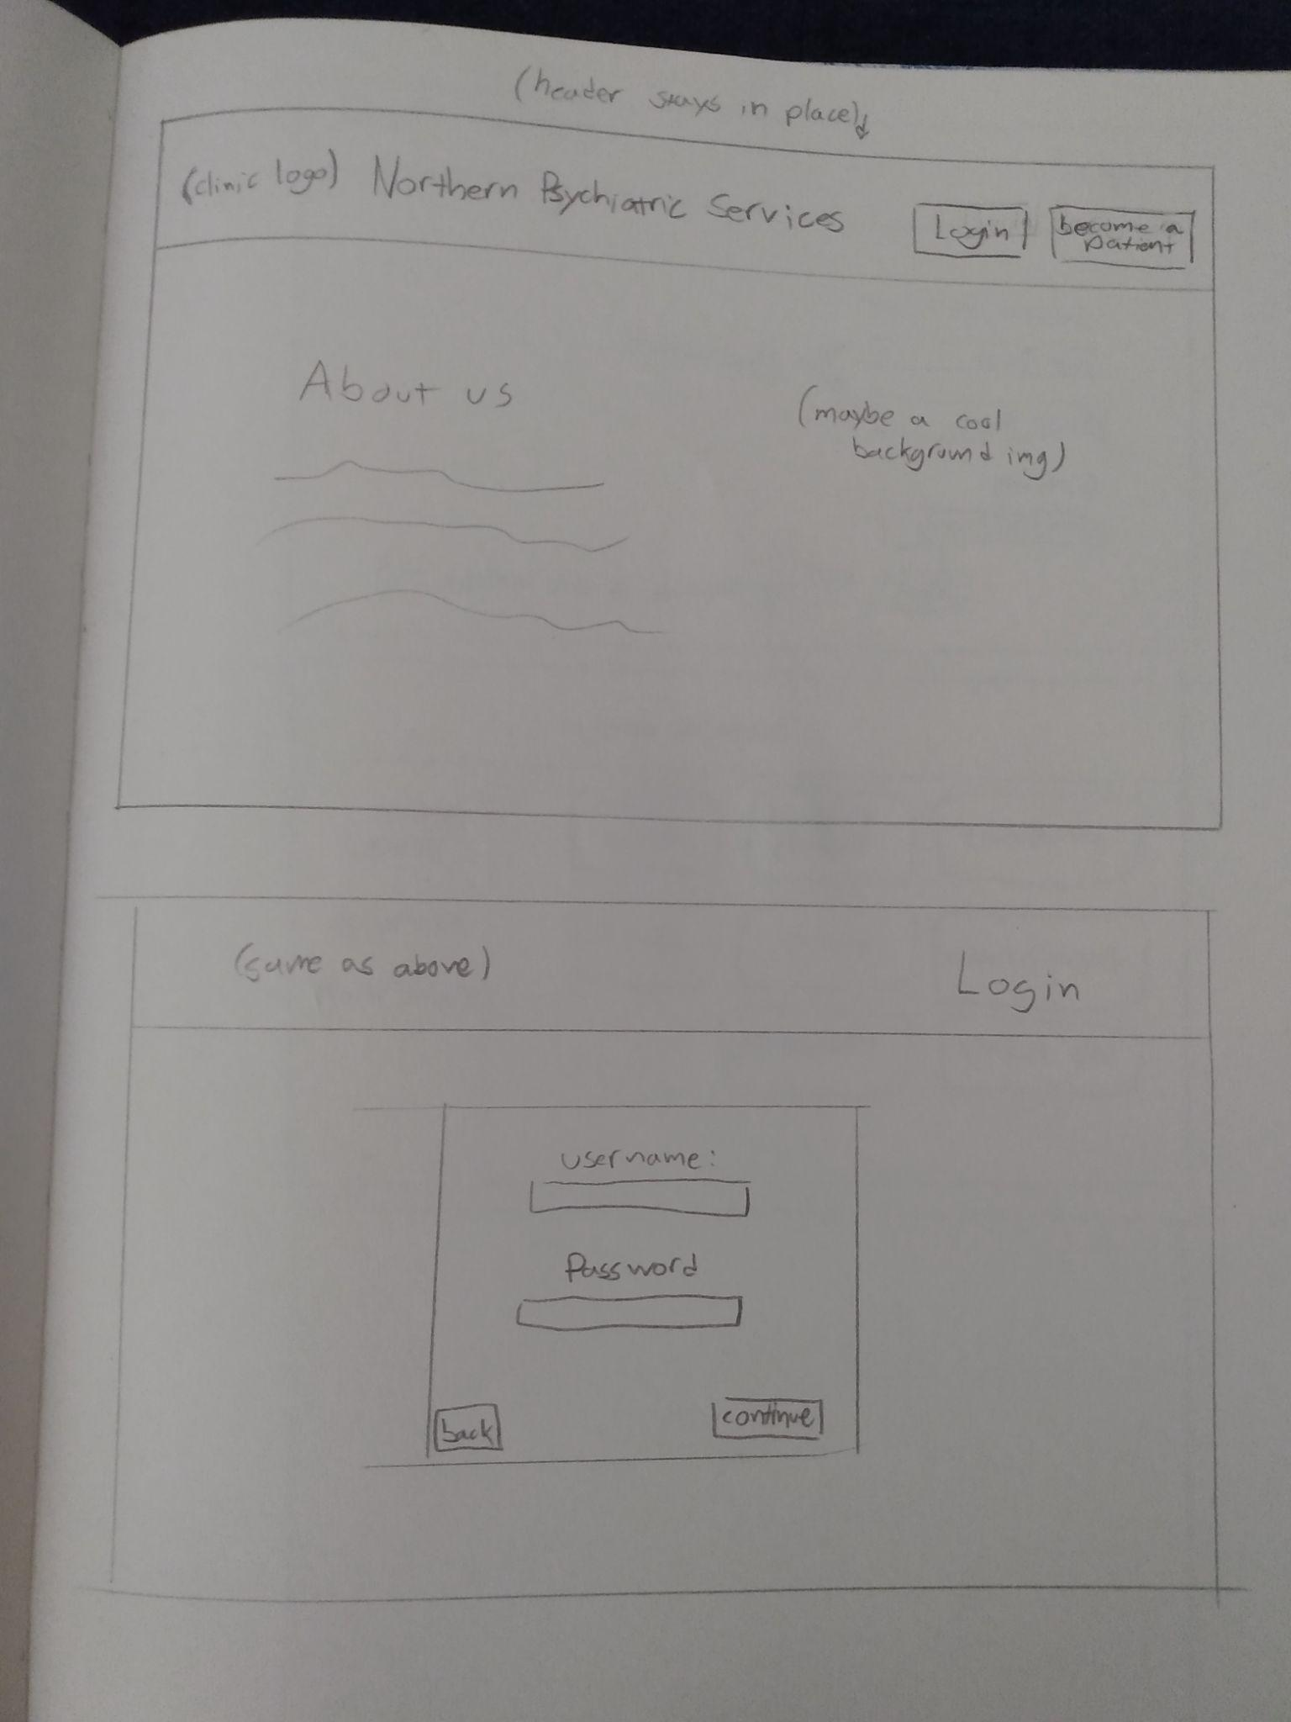

Landing Page & Login Drafts: Text

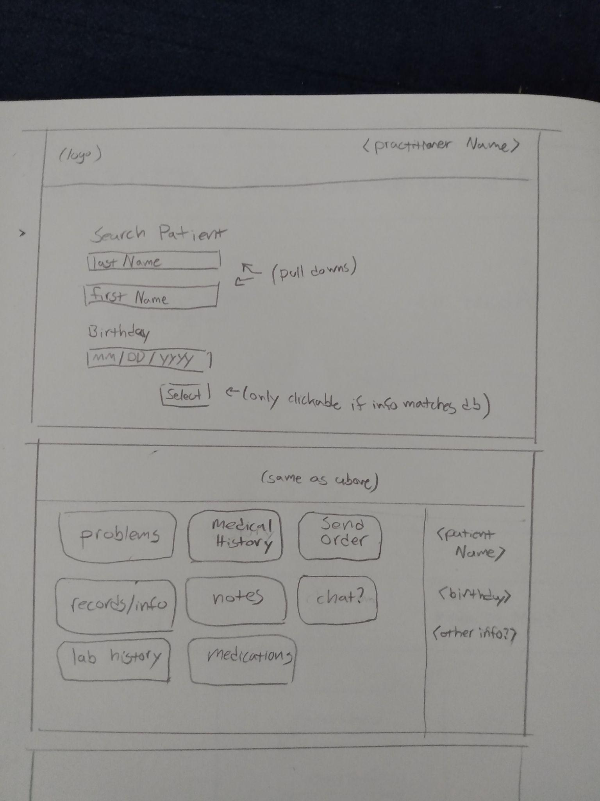

Calendar List View Draft: Text

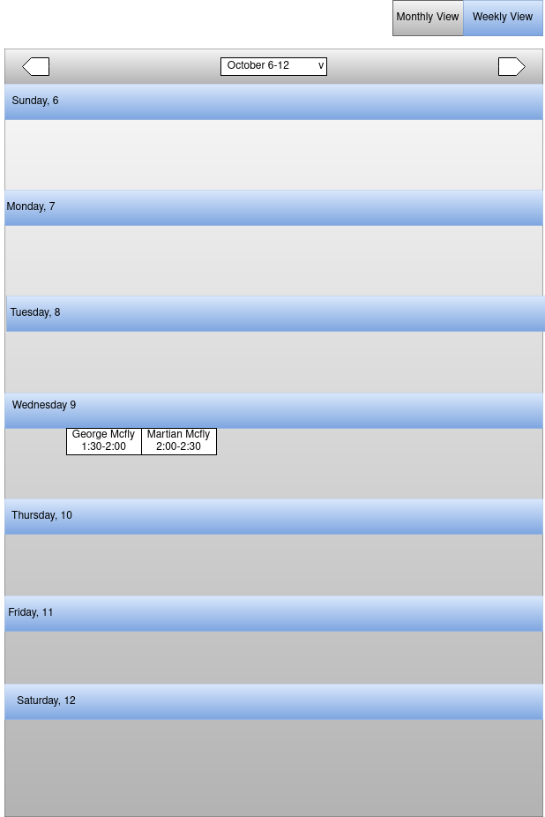

Calendar View Draft: Text

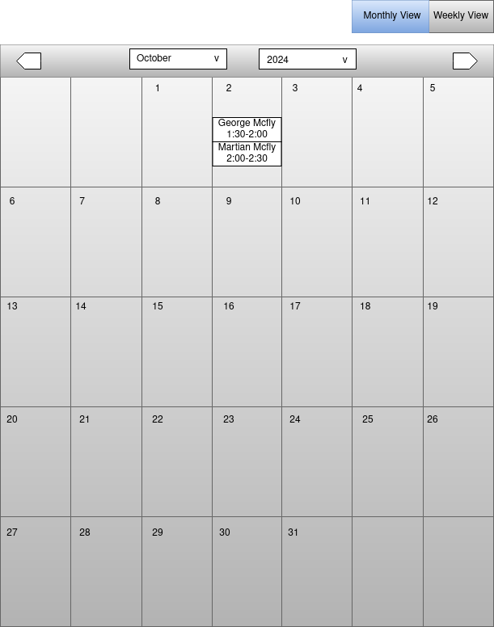

**David:**

Practitioner View Draft (Version 1): The original took inspiration from a previous project when designing the architecture shown below. The images are unorganized but they comprise the home, calendar, work orders, add patient, and notes pages with their various states.

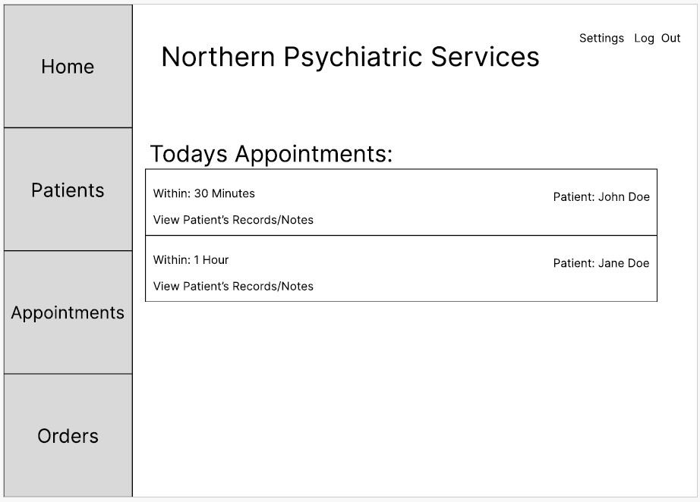

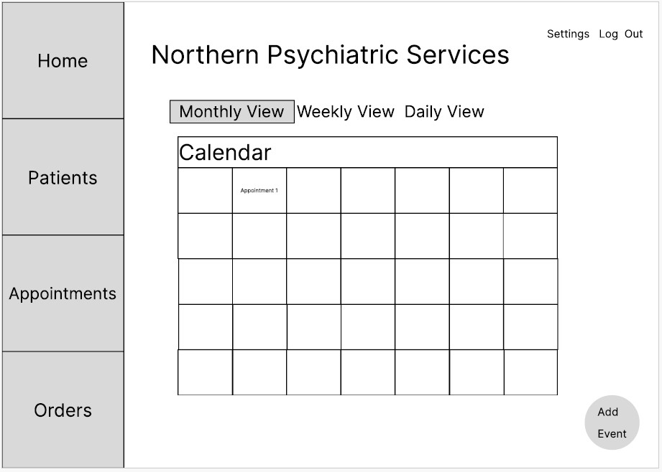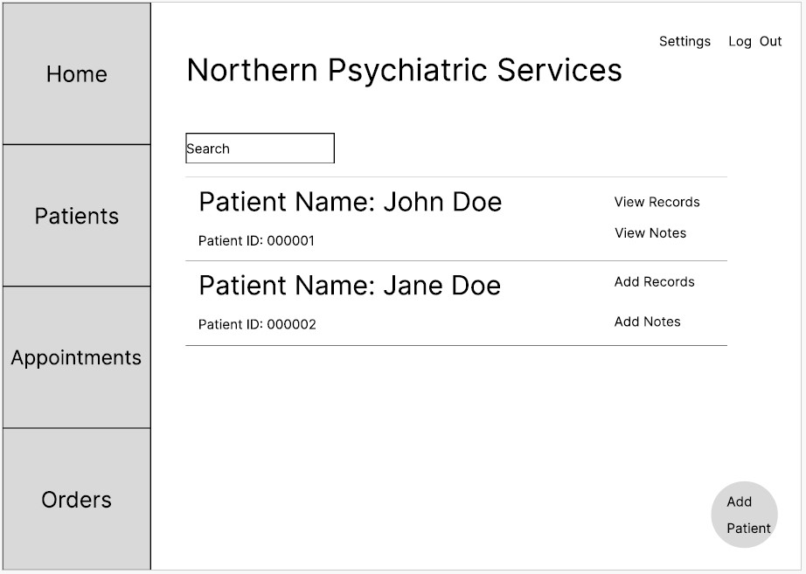

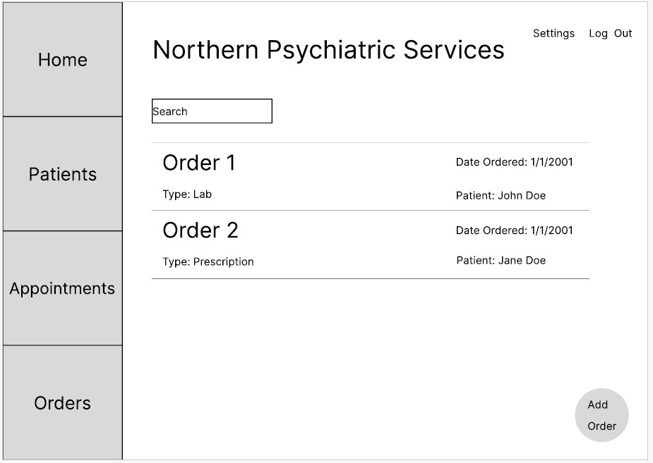

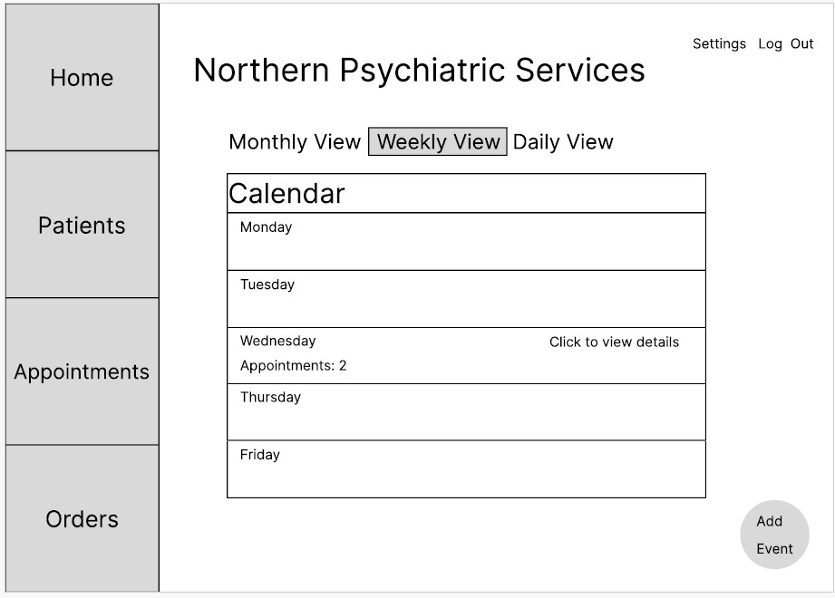

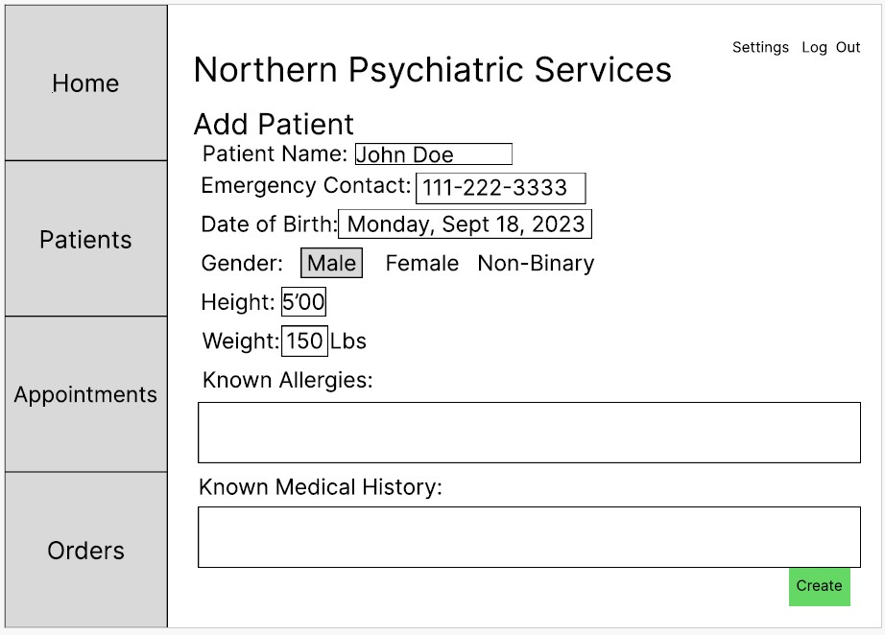

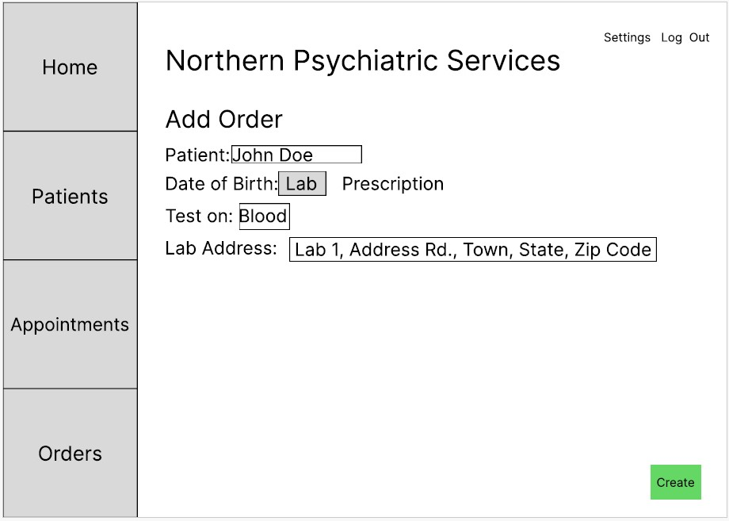

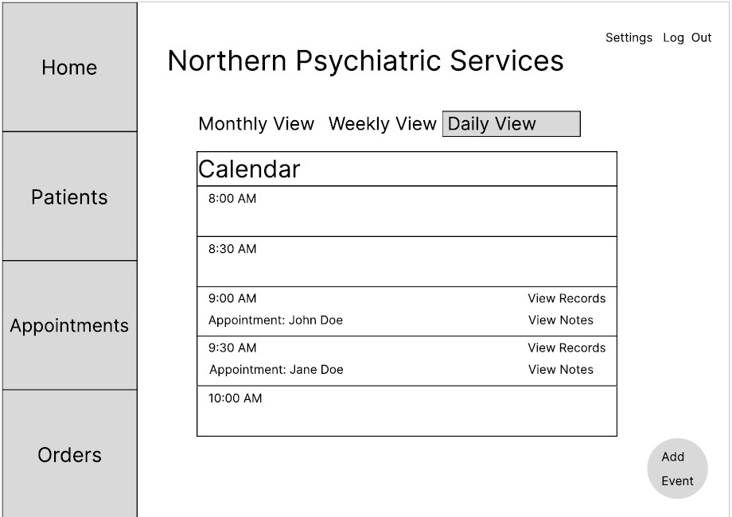

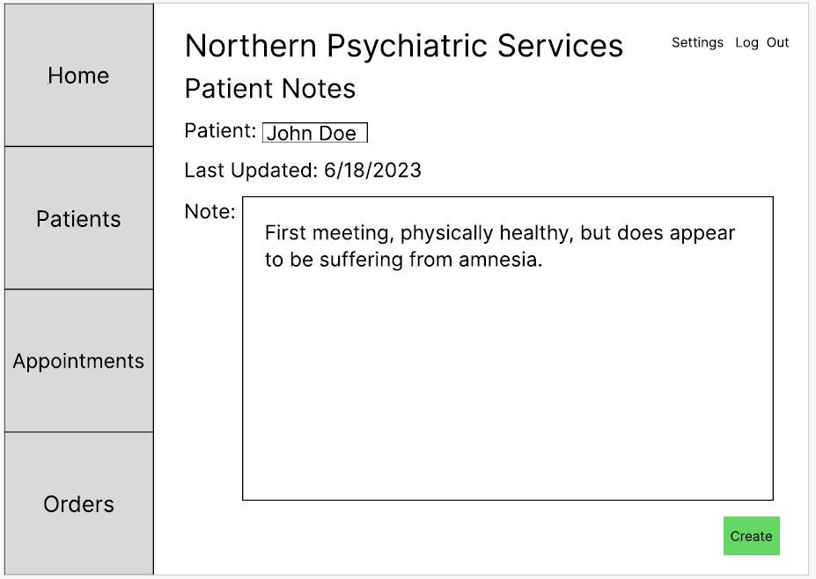

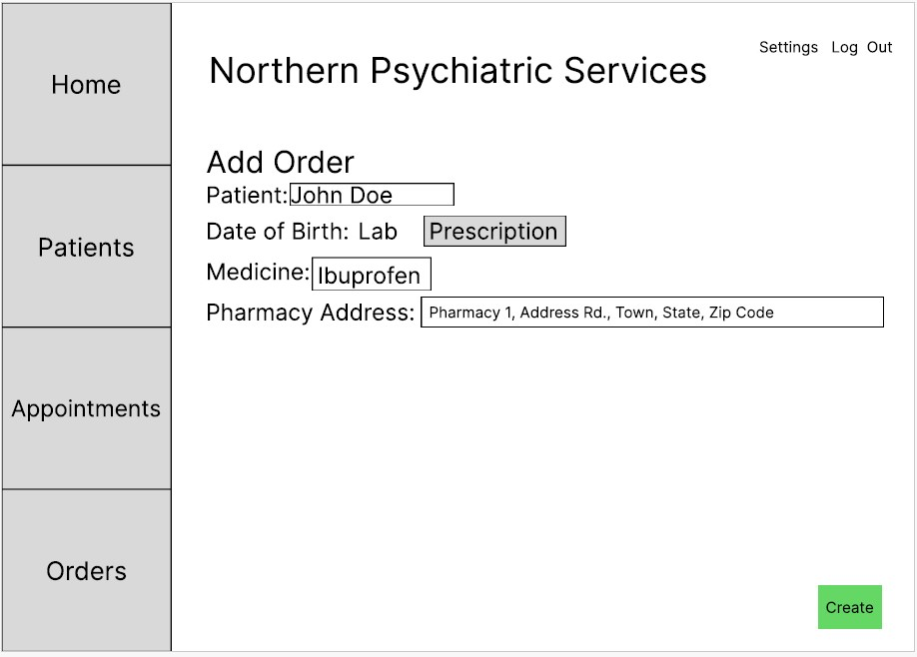

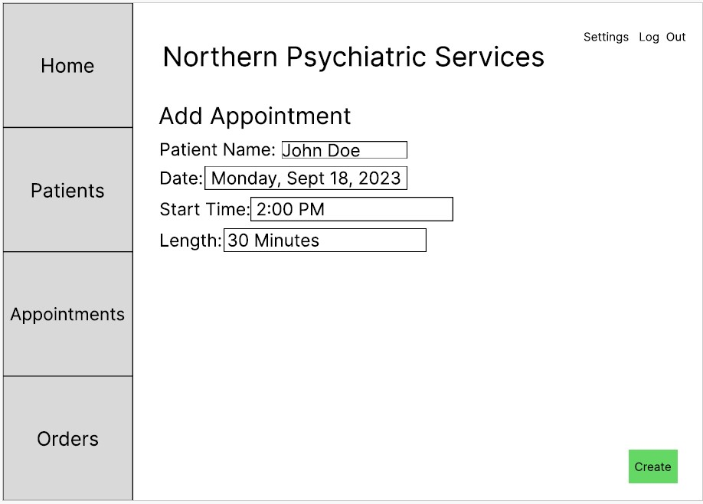

Practitioner View - Billing Statement Mockup (Version 2): After we as the interface group agreed on a design architecture we were sticking with, I was assigned to do the Billing Statement page and designed it like the below image.

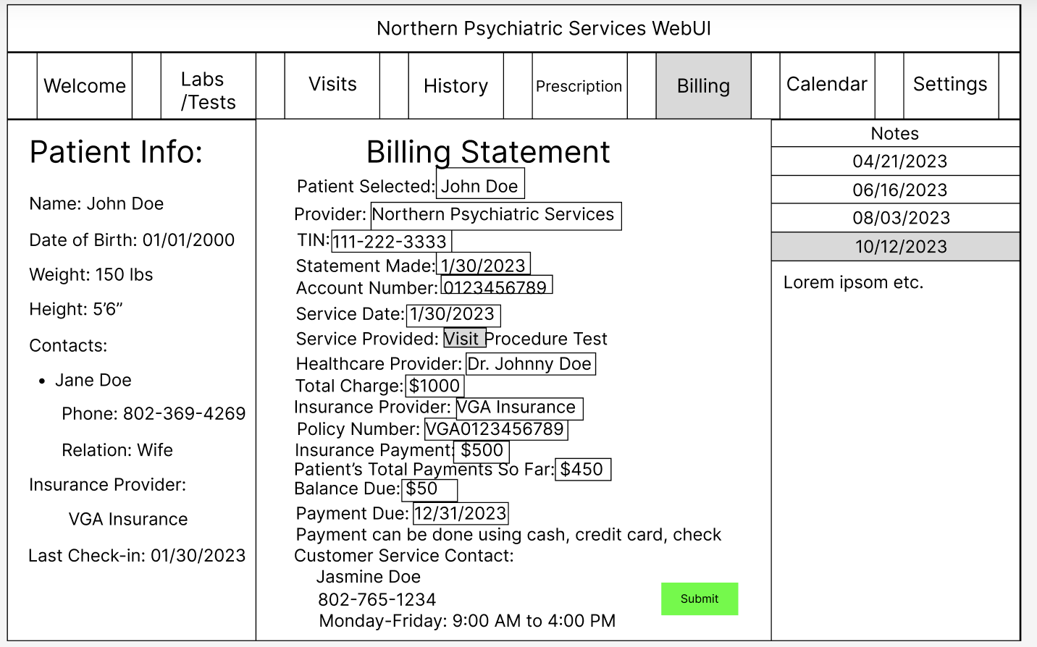

**Josh:**

Receptionist & Practitioner initial renderings: I researched a few of the commercial EMR systems available on the market to come up with these. I envisioned going with a similar design initially that used a system, such as Epic, as its model.

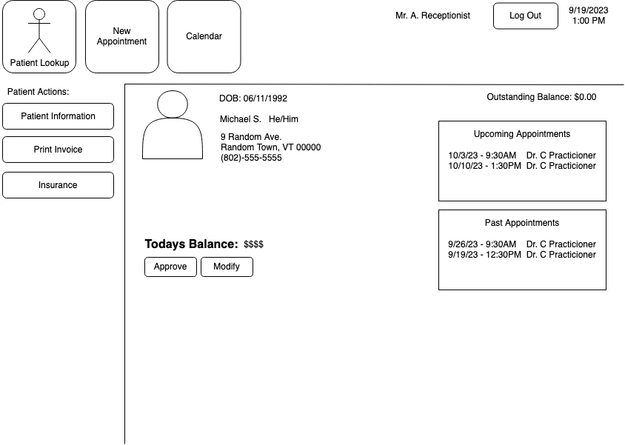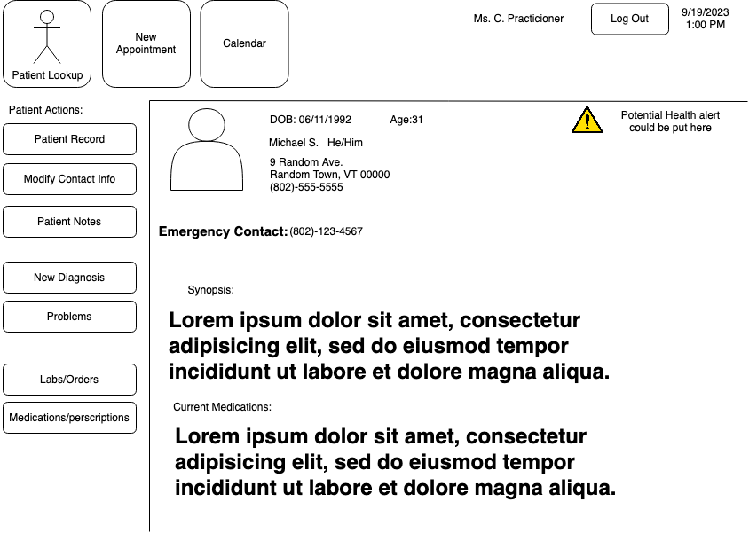

Portal initial rendering: I wanted to model a system similar to the MyChart system Epic develops. However, the group as a whole quickly tabled this design as it shares similarities with the VSC student portal, which has a reputation for providing a poor user experience

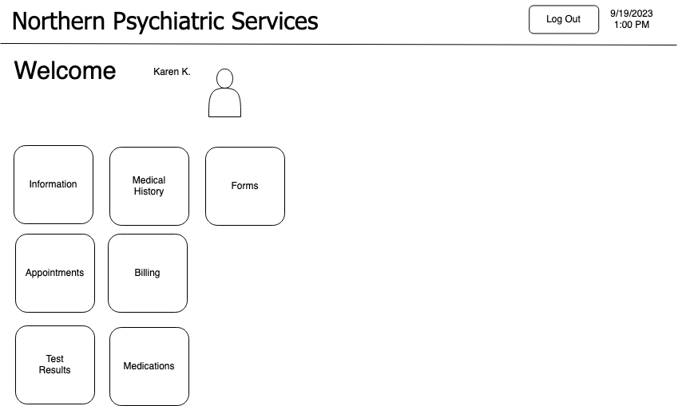

Practitioner and receptionist - Initial Calendar Renderings: Text

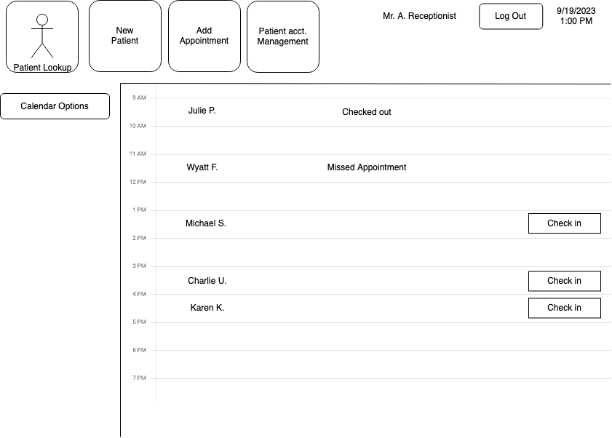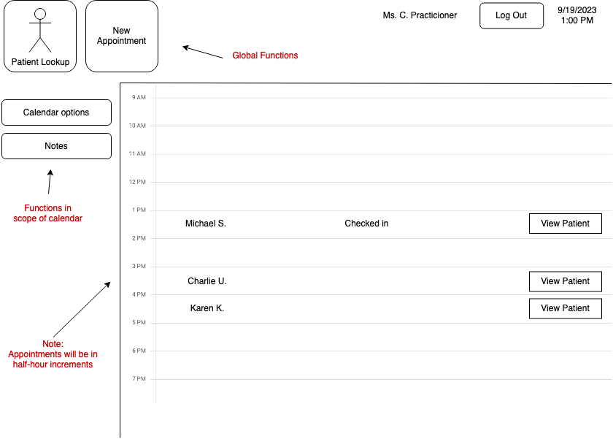

Final renderings: Ryan proposed a frame layout to the group, and each of us was happy with this design. The three renders are the medical records and patient history pages integrated into Ryan’s multi-frame interface.

Practitioner View - Medical Records Integration:

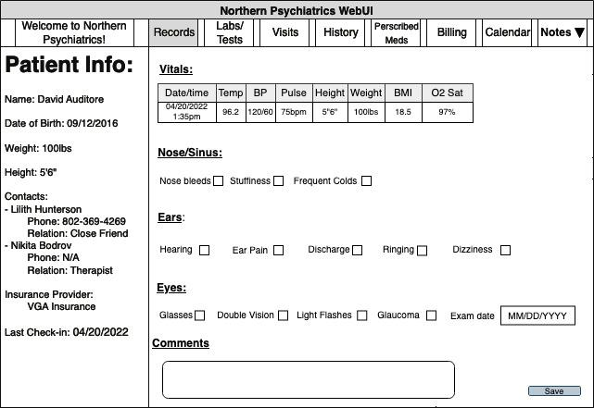

Practitioner View - Medical History Integration-A:

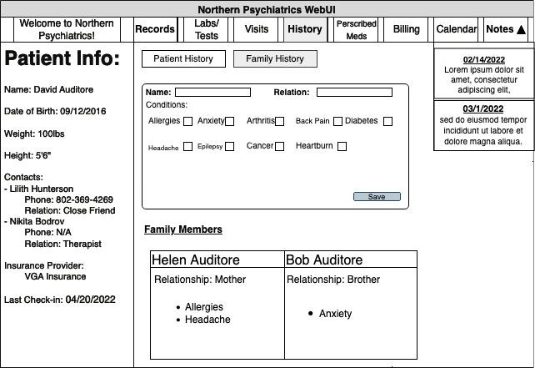

Practitioner View - Medical History Integration-B:

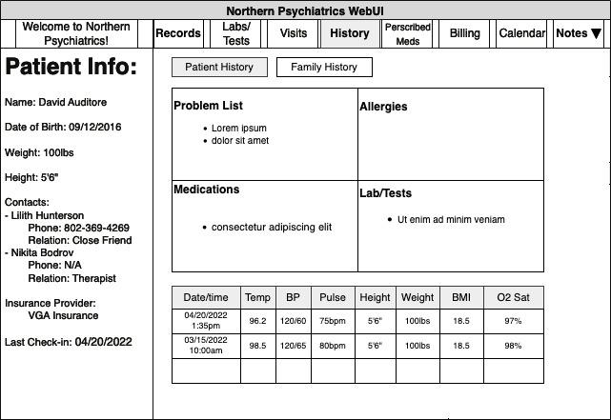

**John:**

Prescriptions Outline: Text

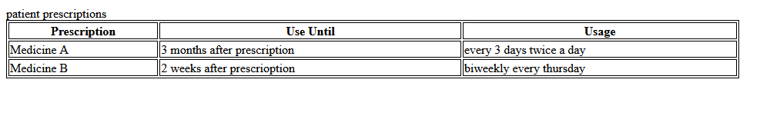

**Ryan:**

UML Practitioner View Complete: The blow drawings were what I had come up with originally for the overall UML, but we all expanded upon them and tried to standardize them for the practitioner view. We had intended there to be multiple views (Admin, Patient, Receptionist, Practitioner), but we were unable to realize those ideas, as the database wasn't functional until the end of November, and we simply had no time to add that feature. We also considered adding a chatbox, but that was scrapped early on, alongside the “Welcome to Northern Psychiatrists!” Logo.

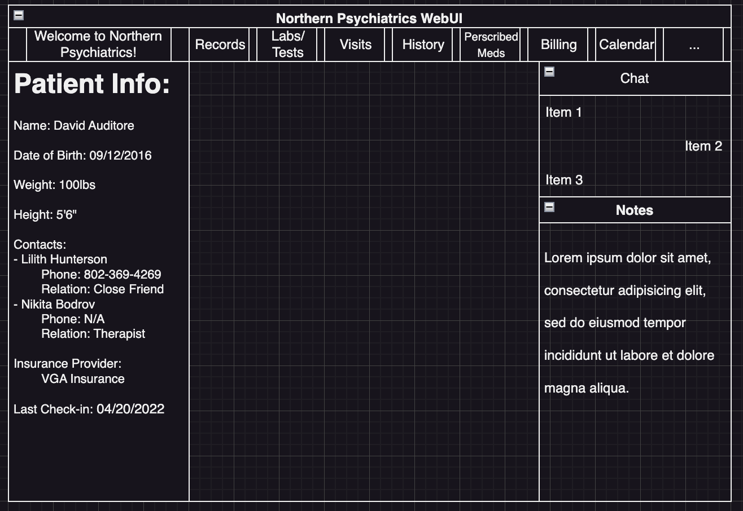

Below is an updated version of the practitioner view, which cut out the chatbox, simplified the top index bar, and added some more details to the side patient info box. It also includes buttons to view a patient’s medical and family history, but those would be moved to the top index bar in the final draft. We also had the idea to have the notes panel collapsible, but that never got implemented, due to us choosing to go with frames and time constraints.

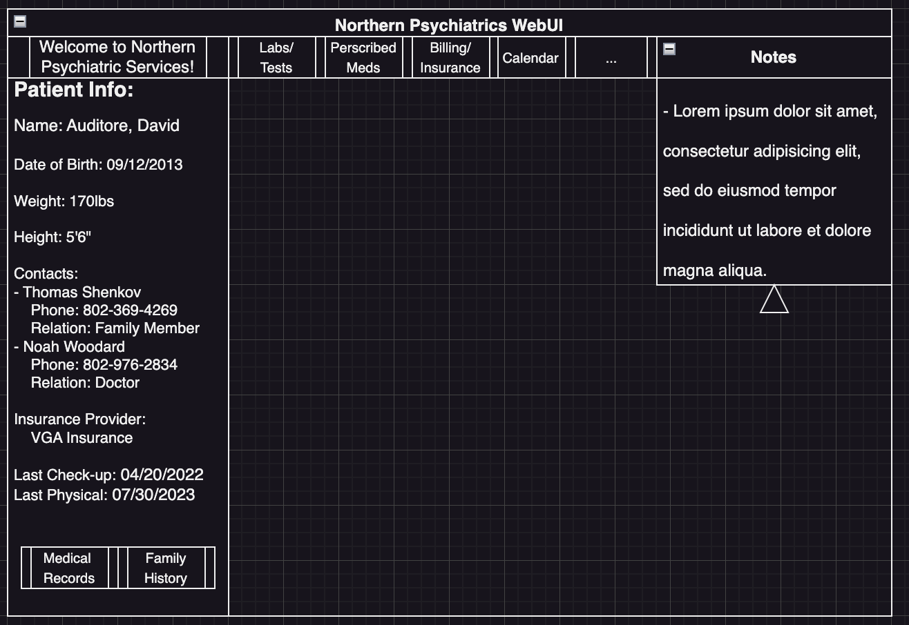

Below is how the notes feature would’ve functioned. You would click on a note entry in the practitioner view, which would then look it up in the database before displaying what was written at that date. If you added/removed a note, it would reflect both in the database and on the website.

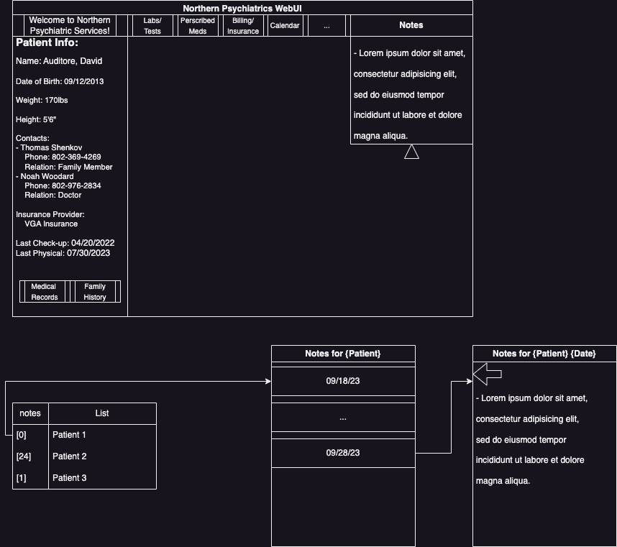

**Alex**:

Work orders Page Lineart:

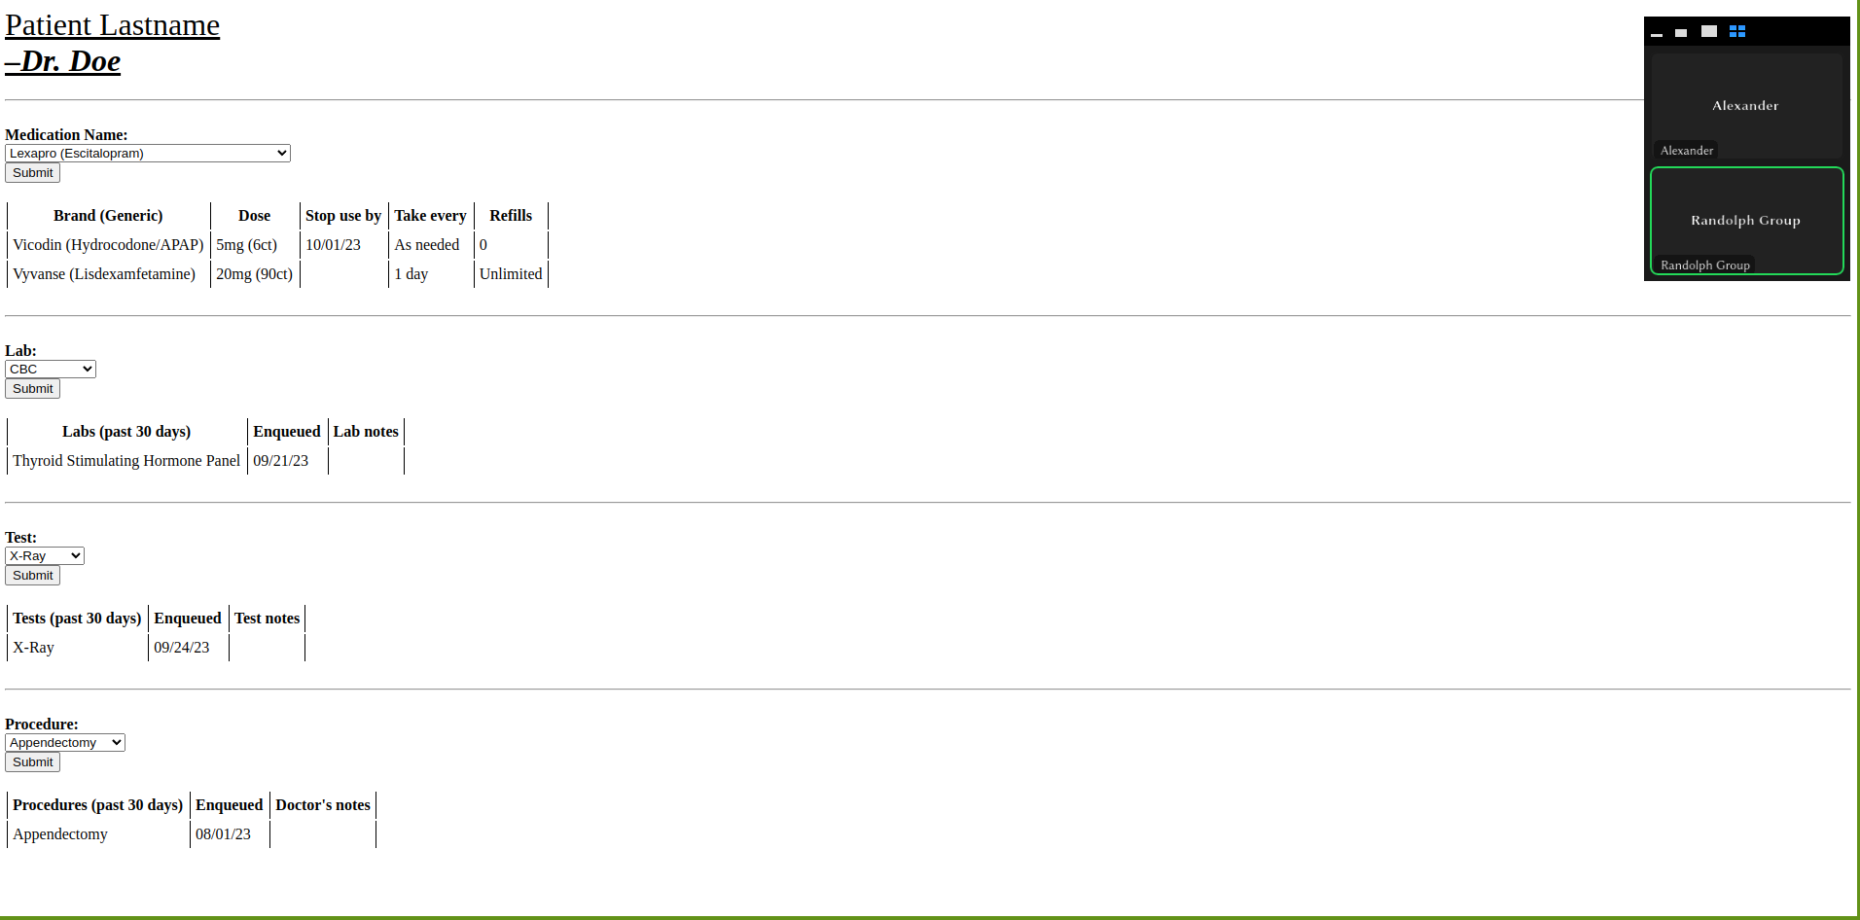

Database (Luke):

